Ministry of Agriculture of the Republic of Kazakhstan

Kazakh National Agrarian Research University

"APPROVE"

First Deputy Chairman of the Board - Rector

_______________ P. Ibragimov

"__" _________ 2024

REPORT

about the results of your business trip

within the framework of the BR 24993222 program "Building a decision support system for the natural and economic development of the territory of the North Kazakhstan region in the context of sustainable development"

from 05 to 10 November 2024

in Petropavlovsk, North-Kazashtan region

Almaty, 2024

**REPORT**

**on the results of a business trip within the framework of the BR 24993222 program "Building a decision support system for the natural and economic development of the territory of the North Kazakhstan region in the context of sustainable development" from November 05 to November 10, 2024**

**in Petropavlovsk, North-Kazashtan region**

By order of the First Deputy Chairman of the Board – Rector of the Kazakh National Agrarian Research University P. Ibragimov dated November 04, 2024 No. 366-i/s,была командирована a group of scientists г. from Petropavlovsk (North Kazakhstan region) was sent to the Department of Agriculture and Land Relations of the Akimat of the North Kazakhstan region from 05.11.2024 to 10.11.2024 for 6 days in order to data collection for the implementation of the BR 24993222 program "Building a decision support system for the natural and economic development of the territory of the North Kazakhstan region in the context of sustainable development" approved by the Science Committee of the Ministry of Science and Education of the Republic of Kazakhstan dated October 01, 2024 No. 398/PCF 24-26.

1. **Department of Agriculture and Land Relations**

On November 6, we visited the municipal state institution "Department of Agriculture and Land Relations of the Akimat of the North Kazakhstan region". We met with the head Tokuzhinov Dauren Maratovich and deputy head of theManagement Board Suleimenov Zhalgas Serikbayevich.

Department of Agriculture and Land Relations of North Kazakhstan Region

Address: Petropavlovsk, Parkovaya str. 57B;

Phone: 8 (7152) 533620

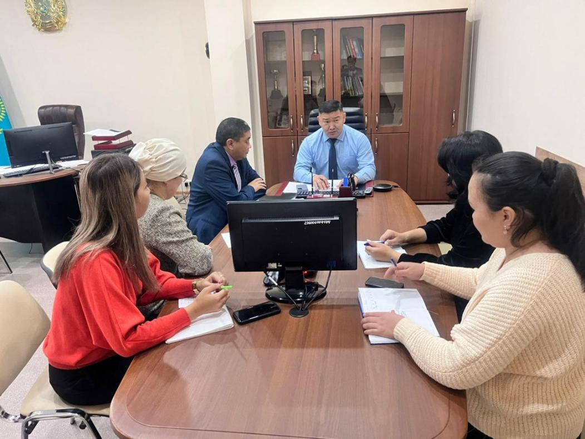

Figure 1. Meeting with the head of the Department of Agriculture and Land Relations of the North Kazakhstan region Tokuzhinov Dauren Maratovich

During the meeting, the purpose of our visit was discussed, negotiations on cooperation were held, the head of the Department of Land Relations Tokuzhinov Dauren Maratovich noted the current state and topical issues of the North Kazakhstan region.

As a result of the meeting, it was found that there are the following problems in the region:

- ahigh level of repatriation of citizens resettled within the framework of the national project "Strong Regions-a driver of the country's development", unable to adapt to the climatic conditions of the North Kazakhstan region;

- currently, the maintenance of cattle in rural settlements is not advisable, the reason for this is the human factor, that is, the reluctance of the population to work in this area, the high cost of feed;

- lack ofadvertising, lack of marketing reflecting the positive aspects of the North Kazakhstan region;

- lack ofgas supply to the gas system in the region;

- in order to prevent such disasters as floods in the spring of 2024, water protection dams are being built in the region, as well as 8 dams are being restored fromфонда «the Demeu fund» in the amount of 5 billion tenge;

- at the time of the flood, reservoirsa were not ready.

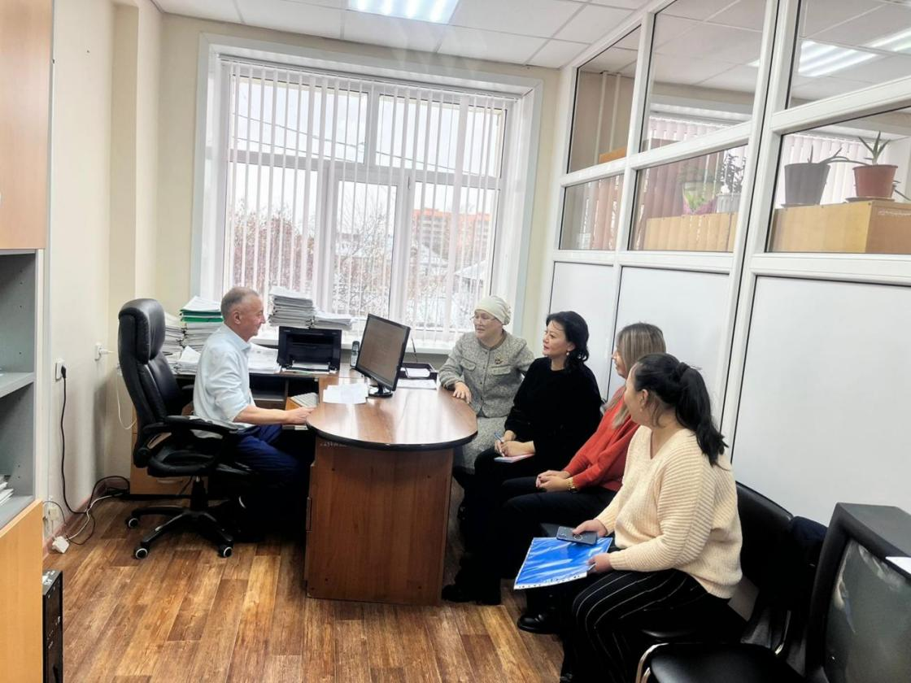

Figure 2. Meeting with the head of the Department of Land Accounting, Withdrawal and Provision of Land Plots Tuleev Marat Kakenovich

We met with the head of the Department of land registration, withdrawal and provision of land plots Tuleyev Marat Kakenovich and with the head of the Department of Land Management, Forecasting, land use Sabit Zhaslan Berikovich.

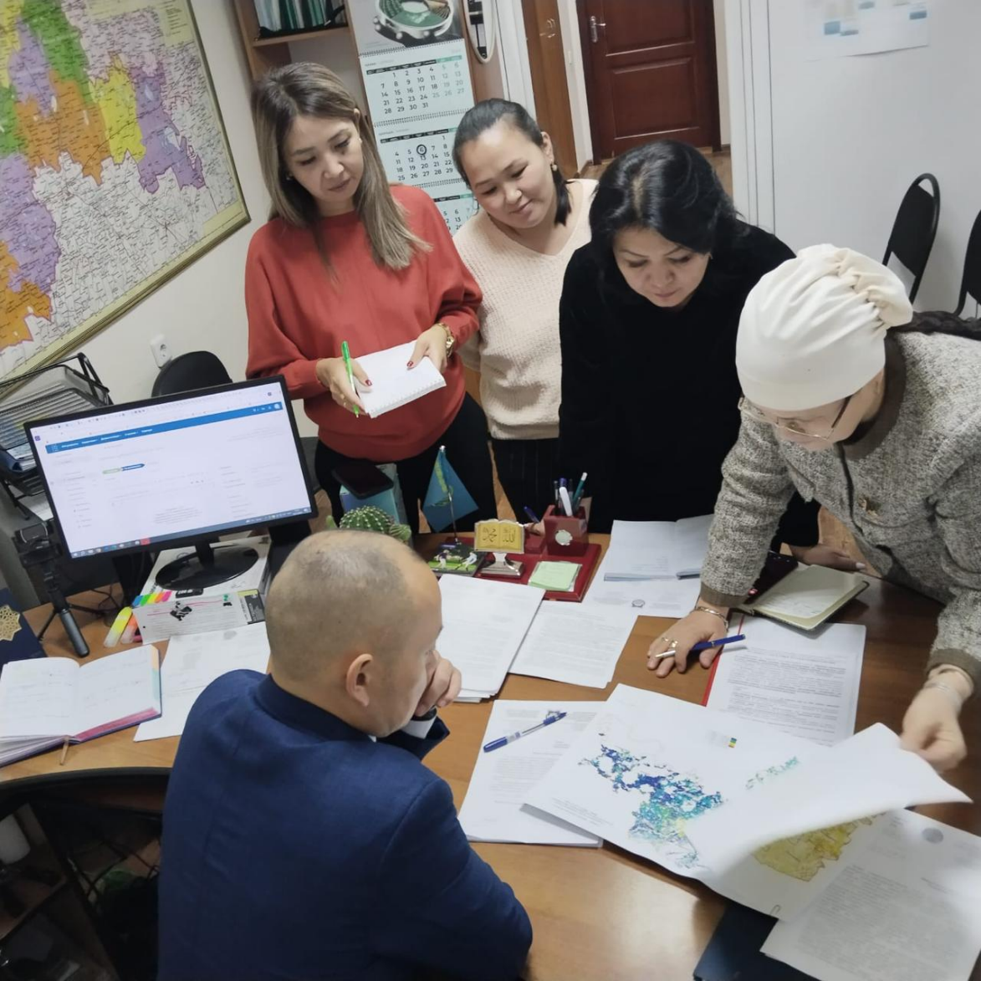

Figure 3. Meeting with Head of the Department of Land Management, Forecasting, Land Use of Sabit Zhaslan Berikovich

As a result of the meetings, the following documents and materials were received:

1. Report on land registration of the region (districts) for 2005-2023-2023 годы(Form No.22);

2. Cartograms of the results of agrochemical research;

3. Information on unused pasture land by district, 2024;

4. Report on the state of land and its use for 2023 by district;

5. . Information on the score of soil yield of agricultural lands as of 01.01.2024 by districts;

6. Information on auctions for the right to sell land plots or lease land plots by district (2018-2023);

7. Information on the number of subsurface users in the region as of November 1 2023 , 2023

8. Decision of the maslikhat of the North Kazakhstan region on the minimum size of agricultural land plots assigned in connection with local conditions and features of the use of these lands provided for ownership or land use in the North Kazakhstan region (approved by the joint decision of the maslikhat of the North Kazakhstan region dated 20.01.2022 No 13/4 and the resolution of the akimat of the North Kazakhstan region dated 21.01.2022 No 10);

9. Information on the number of agricultural entities of the North-Kazakhstan region, that have land of common shared land use as of November 1 2023 , 2023;

10. Information on the return of unused and transferred in violation of the legislation agricultural land in the North Kazakhstan region in 2022-2023 (in the context of districts);

11. Information on the tender for granting the right to lease agricultural land;

12. Information on the analysis of changes in the content of humus and bonitet by crops in the period 2012-2023;

13. Schematic map of salinity of irrigated lands in the North Kazakhstan region based on the results of agro-reclamation research for 2022-2024;

14. Information on space control of pastures in the North Kazakhstan region of the Republic of Kazakhstan;

15. Data on the sowing and technical conditions of pastures (2023);

16. Geobotanical map of the North Kazakhstan region (research results of 2009-2023);

17. Certificate of availability and use of land in the North Kazakhstan region as of November 1, 2023;

18. Decree of the Government of the Republic of Kazakhstan on the maximum (maximum) sizes of agricultural land plots by types of agricultural land within the Republic and one administrative district (city), region, agricultural production of the Republic of Kazakhstan in the North Kazakhstan region without foreign participation and its affiliated persons for maintenance, which may be on the right of temporary land use with a non-state legal entity persons (of the Republic of Kazakhstan Approved by the Decree of the Government of the Republic of Kazakhstan dated January 25, 2023 No 42);

19. Main indicators of the labor market of the North Kazakhstan region for 2014 - 2024.

You need to send an official request for additional data.

1. **Land Inspection Department**

There was a meeting with the state inspector of the Land Inspection Department for the North Kazakhstan region Aitbay Kabidenovich Baidusenov, and Appendix No3 to the report "1-zher" on state control over the use and protection of land in relation to the subjects of land legal relations in the North Kazakhstan region for January-October 2024 was received. You need to send an official request to obtain the necessary data. Aitbay Kabidenovich Baidusenov, 87774171848 Petropavlovsk, Internatsionalnaya Street, 70.

According to the information, in the Aiyrtau district in the settlements of Burlyk, Syrymbet, the highest quality of pastures provides the best quality of meat. Accordingly, there is a possibility of propagation of the grass stand of these pastures and application in other areas.

1. **State Corporation "Government for Citizens"**

We were in the State Corporation Government for Citizens, but the director Zhumabay Yerkin Kyzyruly and the deputy director Suleimenova Kenzhekei Kabdollaevna were not in place. You need to send an official request to obtain the necessary data.

It is also necessary to send a request to the State Institute for Land Surveying, the Department of Construction, Architecture and Urban Planning of the Akimat of the city of Petropavlovsk to obtain master plans of settlements and their development plans indicating engineering communications at a scale of 1:1000, 1:2000, 1:5000.

**Water resources**

1. **LLP "Kyzylzhar Su"**

The following materials were received:

1. Pasport of water management facilities of "Kyzylzhar su"LLP

2. Reservoirs of the North Kazakhstan region (Bioprud reservoir, Gorkoye, Yesil dam, Zeleno-Gay reservoir, dam, Kobensay dam, dam to protect the village of Kozhevenny from the Yesil River, Leningrad reservoir-platinum, Omutskoye reservoir, Petropavlovsk hydroelectric complex, Kyzylzhar district, dam to protect the village of Pribrezhnoye, pond located 1 km from the city of Sergeevka - water collector, channel passport of the reservoir of the Sergeevsky hydroelectric complex on the Yesil River, dam to protect the village of Teplichnoye Kyzylzhar district, technical passport of the dam of the Petropavlovsk hydroelectric complex on the Yesil River, dam adjacent to the reservoir in the village of Tleusai, dam protecting the foothill part of the city of Petropavlovsk from the Yesil River, Charyk reservoir);

3. Register of water bodies of the North Kazakhstan region;

4. Information on the transboundary river Yesil;

**5. Territorial Department of the Yesil Basin Inspectorate**

Head of the Territorial Department of the Yesil Basin Inspectorate Asiya Kairovna Yesimseitova 8 701 871-07-19. Address: Petropavlovsk, st. Karim Sutyusheva, 58.

It is necessary to send a request to the management of the Yesil Basin Inspectorate (Astana) to obtain the following data:

- List of water users with specified limits

- List of water bodies with characteristics

- List of water facilities with characteristics

According to A. Yesimseitova, there are about 3000 water bodies in the region. Of these, data are available for 2328. There is also irrigated land, mainly using rain machines. Water protection zones have been established on 92 water bodies in accordance with PPRK 514 of 31.12.2012.

A. Yessimseitova notes the following causes of floods that occurred in 2024:

- Akmola region has carried out dredging operations in the Yesil River. No dredging operations were carried out on the territory of the North Kazakhstan Region. As a result, 4 days received 4 mdrd cubic meters of water with which the Esil riverbed in the North Kazakhstan region could not cope. As a result, Kyzylzharsky district and Petropavlovsk suffered. General period of increase in water resources due to meltwater and precipitation 01.04-15.07. In 2024, over the entire period, 8 billion cubic meters of water were received in excess of the norm.

- Ice jams. In 2024, ice blasting operations on the Yesil praktichnski River were not carriedout. Accordingly, it is necessary to increase funding for ice blasting operations.

. As a result, there were ice jams that cluttered the riverbed, preventing the further flow of water from curtailing the norm.

Also, according to A. Yessimseitova, it is necessary to:

- carry out dredging along the entire Yesil River.

- restore broken riverbanks

- perform a bathymetry of the river bottom. This year it is planned to conduct a bathymetric survey on a section of the river with a length of 40 km. Although it is necessary to spend 690 km on the entire length of the river. If there is an extreme lack of resources, a bathymetric survey should be carried out from the Sergeyevsky reservoir to the border with the Russian Federation.

- the situation has shown that water storage facilities cannot cope with ice jams. Therefore, it is necessary to build bypass channels of the Petropavlovsk reservoir to drain water.

- It is necessary to build a counter-regulator between the Akmola and North Kazakhstan regions. This will ensure that some of the water is saved for agriculture and other water users during the summer season.

- Underground water storage as suggested by German technologies will not be possible to apply in North Kazakhstan region, as the ground water rose this year.

1. **Branch of RSE Kazvodkhoz for North Kazakhstan region.**

Address: Petropavlovsk, Karim Sutyushev str., 58.

The branch is responsible for three objects–: theодохранилища Sergeyevsky, Petropavlovsk, and Sharyk storage facilities. Contacts: 87777912444 Elena Chief specialist of the GTS Operation Department,

The following data and characteristics of reservoirs are provided:

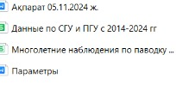

1. **Regional State Institution "Kazhydromet" of North Kazakhstan region.**

Address: Petropavlovsk, Parkov strя., 57.We met with the director of the regional state institution " Kazhydromet” Mergalimova Kymbat Gumarbayevna and Deputy Director Levina Natalia Viktorovna. During the meeting, the state agency Kazhydromet presented the following information.

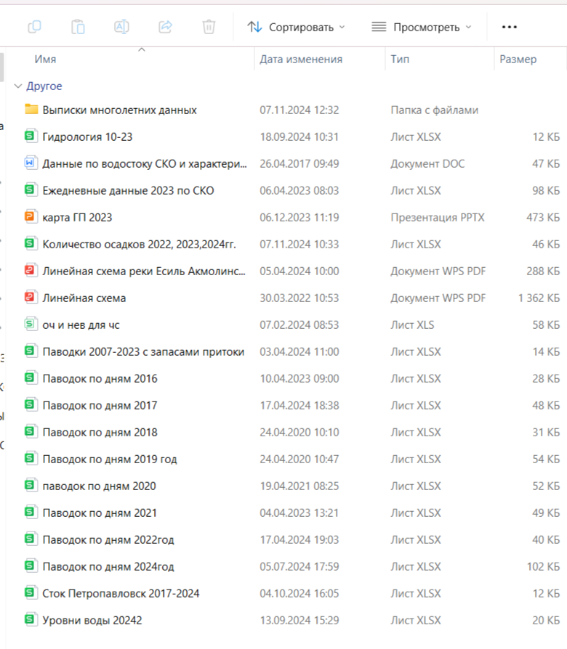 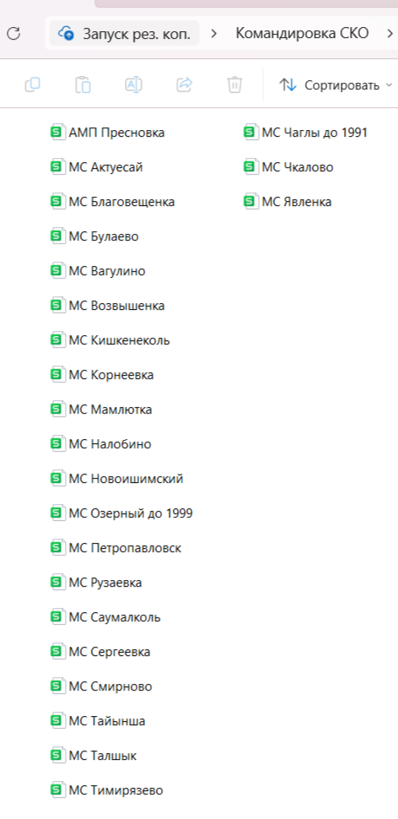

1. **Forestry**

We met with the head of the State Forestry Institution of the North Kazakhstan region Lavantyuk Vasily Alekseevich. Rustem Zhanakhmetov, Forest Protection Engineer of the Kyzylzhar Forestry, provided reports of the Kyzylzhar Forestry for 2021, 2022, 2023, 2024 and scanned versions of the fire log and explanatory notes.

Contacts: 87477544165-Rustem Kayyrzhanovich Zhanakhmetov, Forest Protection Engineer of KSU "Kyzylzharskoe Forestry"; 87152543639-Vasily A. Lavantyuk, Head of the Department of Forestry and Special Protected Areas; 87152533645-Ainura Bekbolatovna Umurzakova, Chief Specialist of the Department.

To obtain additional data on the remaining forest holdings, you should officially send a request letter to руководителяthe heads of the State Forestry Agency of the North Kazakhstan Region.

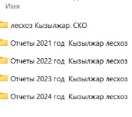

1. **Animal world**

We met with Oleg Bespalov, inspector of the Republican State Institution "North Kazakhstan Regional Territorial Inspectorate of Forestry and Wildlife of the Forestry and Wildlife Committee of the Ministry of Ecology and Natural Resources of the Republic of Kazakhstan".

The Inspectorate is a territorial subdivision of the Forestry and Wildlife Committee of the Ministry of Agriculture of the Republic of Kazakhstan, authorized to perform implementation, control and supervisory functions in the field of forestry and wildlife, specially protected natural territories. The Inspectorate is authorized to control, supervise and coordinate the activities of the Kokshetau State National Nature Park, within its competence and protect the Mamlyut and Smirnovsky State zoological nature reserves, as well as on the reservoirs of the Yesil basin (including water protection strips and zones, coastal strips and sanitary protection zones) within the administrative border of the North Kazakhstan region.

All necessary documents, in particular information about the wildlife of the North Kazakhstan Region, will be sent to your personal email address on 11.11.2024.

Bespalov Oleg Borisovich; Phone: +77052911240

Address: 58 Karim Sutyushev Street.

1. **Department of Natural Resources and Environmental Management**

Municipal State Institution "Department of Natural Resources and Regulation of Nature management of the Akimat of the North Kazakhstan region" is a state body of the Republic of Kazakhstan that provides management in the field of forestry, hunting, fishing, water management, specially protected natural areas of environmental protection and other objects of animal and plant life in the territory of the North Kazakhstan region. Head of the Department Ismanov Beibut Kairkeshevich; Working phone: 8(715) 2533647; Address: Petropavlovsk, Parkovaya str. 57B, office 429.

To obtain data and materials, it is necessary to send an official request to the Department of Natural Resources and Environmental Regulation of the Akimat of the North Kazakhstan region.

1. **Department of Ecology of North Kazakhstan Region**

We met with a specialist of the Republican State Institution "Department of Ecology in the North Kazakhstan Region of the Committee for Environmental Regulation and Control of the Ministry of Ecology and Natural Resources of the Republic of Kazakhstan". To obtain data and materials, it is necessary to send an official request to the Department of Ecology in the North Kazakhstan region.

1. **Information about transport resources**

A meeting was organized with the head of the Department of Housing and Communal Services, Passenger Transport and Highways of the Akimat of Petropavlovsk. Introductory work was carried out on the program "Building a decision support system for the natural and economic development of the territory of the North Kazakhstan region in the context of sustainable development", during the meeting, all documents and passports for rail transportation, air transportation and bus stations, passenger transportation for the entire period of work were collected. All contacts were collected for further cooperation.

The Department of Transport Roads shared information on the condition of regional and district roads up to village roads. The Transport Department of Agriculture has prepared a list of equipment for equipping the North Kazakhstan region with agricultural machinery. In the context of 2012 to the present day. The scheme of the roads of the North Kazakhstan region and information on transport resources were also obtained.

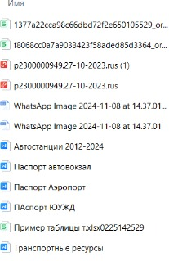

1. **Information about communications**

A meeting was organized in the Akimat of the North Kazakhstan region on the equipment of communication (communication) with the head of the Department of Digitalization of the North Kazakhstan region.

We held an introductory meeting, shared with the information of our project "Building a decision support system for the natural and economic development of the territory of the North Kazakhstan region in the context of sustainable development". During the meeting, data were obtained on the provision of Internet to settlements in the North Kazakhstan region within the framework of the National Project in the field of communications "Affordable Internet".

1. **Department of Natural Resources of the Akimat of North Kazakhstan region.**

Address: Petropavlovsk, Parkovaya str. 57B.

Own materials of projects on the establishment of water protection zones.

They contain research materials.

You must send a request.

1. **Department of Statistics of North Kazakhstan Region.**

Address: Petropavlovsk, st. N. Nazarbayev 83. Deputy Director - Zhuldyz Kereevna. User Relations Department Ekaterina Borisovna 87056510313, Olga Bubenko 87773936734. During the meeting, it was noted that all data are posted on the website of the Bureau of National Statistics stat.gov.kz in the REGIONAL DATA section. If you have any questions about the use of the site, you can contact the User Relations Department at the above contacts. If more detailed data is needed, it is necessary to send an official request to the head of the department.

1. **Department of Entrepreneurship**

Address: Petropavlovsk, Constitution str., 58. Beibit Kazbekov Head of the Department of Industry and Subsoil Use +7 701 105 2299.

Получены Two maps with subsurface use itemswere obtained. A register ofsubsurface users was also obtained. The subsurface use reportwas received and scanned.

For solidminerals, request the Ministry of Industry of the Republic of Kazakhstan. For oil and gas, you need to request the Ministry of Energy. Forgeologicdata,bothmapsиmust be requested by the National Geological Survey.

1. **Education**

Department of Education. Fromcases like this. Address: 58 Constitution Street, 6th floor. 36-06-81-06-Bauyrzhan Zhanatuly Zeynullin Head of Department. Riza Boranbaevna +7 777 336 1098 ch. specialist.

Undertook to provide the following data:

- Information on the number of students in colleges of the North Kazakhstan region over the past 10 years;

- The rest of the data from 2004 will be taken from the archive and provided within a month.

According to the Department, there are the following problems:

- Outflow of students;

- Those who come from the southern regions note the cold and return;

- The Serpin program has not been working in the North Kazakhstan region for the last 3 years;

- Rural youth do not enter rural colleges;

- There is an outflow of students to the Russian Federation.

**18. Settlers**

A meeting was held with the head of the public organization "TAUEKEL" Burakhan Dakhanov, who provides consulting support to migrants in the north. Information about displaced persons was received.

There are 25 thousand people left in Shal Akyn district, 12 thousand people in Timiryazev district.

Migration issues arehandled by the Ministry of Labor and Social Protection of the Population of the Republic of Kazakhstan, mainly low-income families came. The issue of land allocation has not been resolved. Forго this purpose, the Ministry of Agriculture of the Republic of Kazakhstan should deal with the migration issue. It is necessary to cooperate with migrants and create conditions forи, интеграциthem to adapt, integrate, and socialize, социализаци.Because in the village they can't adapt. In addition, it is necessary to relocate competitive people, and not just those who are registered asunemployed.

It is also possible to register the immigrant population as a farmer,provide land, grant subsidies, and direct their activities to обеспечprovide agricultural products to neighboringх regionsof Russia (Kazan, Omsk, and Orenburg). The following peaks oflocal population decline are noted:

- the population dropped from 900,000 to 530,000.

- aboutvery few Kazakhs;

- previously deported representatives of other nationalities moved to their countries after 1991;

- a lot of people movedо to Astana;

- as a result of urbanisation, elderly people and parents move to citya for their children. The village of Beskol, which is located near Petropavlovsk, consists of people who moved from other areas.

Recommended measures:

- to ensure that schools do not close, it is necessary to relocate orphans from orphanages.Some schools now have up to 12 students. If школа закроеthe school closes, the village will also cease to exist. There is unemployment and homes remain deserted and , accordingly, there is nodemand for housing.

- count down the time spent in the village for testing convicts under a light article and send на отработкуthem to the villages of the North KazakhstanRegion for working off. But then the North will be associated with a prison.

- to increase the birth rate in the North Kazakhstan region, an ideological approach and interest of the population are needed;

1. **Department of Health**

A meeting was held with Acting Head of the Health Department of the Akimat of North Kazakhstan region-Aldiyar Maratovich. During the meeting, the head of the department showed the functions of the National Statistical Office stat.gov.kz, all necessary data is publicly available. To get information about certain types of diseases, you need to send an official request to the Department of Sanitary and Epidemiological Control of the North Kazakhstan region of the Committee of Sanitary and Epidemiological Control of the Ministry of Health of the Republic of Kazakhstan. To get data from the Department ofEspecially dangerous diseases and tuberculosis, you need to send an official request. Gaisina Yulia Viktorovna prepared the necessary data and направsent it to her personal email address after receiving the official letter.

Aldiyar Maratuly (87479155557)- Acting Head of the Health Department of the Akimat of the North Kazakhstan region.

Gaisina Yulia Viktorovna (87776076509)- Department of Sanitary and Epidemiological Control of the North Kazakhstan region of the Committee of Sanitary and Epidemiological Control of the Ministry of Health of the Republic of Kazakhstan. Department of Especially dangerous diseases and tuberculosis.

1. **Emergency situations**

There was a meeting with the chief specialist of the Department of Emergency Situations of the North Kazakhstan Region of the Ministry of Emergency Situations of the Republic of Kazakhstan Akhmetzhanov Sayan Eginbayevich noted that if an official request is received, all the necessary documents will be sent.

Sayan Akhmetzhanov - Emergency Department of North Kazakhstan Region. Phone: 87758030060.

1. **Regional management**

In order to inform the Akim of the region about the implemented prgoramma, a contact was established with секретаремthe Akim's secretary. As a result of negotiations, it was found out that the Akim of the region is on vacation. In this regard, we were redirected to the deputy akim Zhumagulov Zhusip Rakhatuly. Assistant: Ernar 87074279838. Several negotiations were held with the assistant to the Deputy akim. During the discussion, it turned, out that the program issues cover a larger number ofmembers of the board, and none ofthe acandma deputies are responsible forall issues. As a result, meetings with deputy akims were canceled. A meeting with the akim of the region is required.

1. **The trip also resulted in some suggestions and comments:**

* Consider reinstating the 25% wage supplement in the northern regions as it was in the 1980s. At the same time, in the private sector, the established allowance can be subsidized at the expense of the republican budget

- To conduct psychological research in order to find out the reasons for the departure of local youth from rural areas and the region as a whole;

- To conduct research in the southern regions of Kazakhstan and find out the reasons for the residence of local youth in villages;

- To assess the living conditions of the population in the North Kazakhstan region, including the availability of leisure, utilities (heating, water, sewerage, etc.);

- When developing methods for protecting the population from floods, take into account the rise of underground groundwater and ensure the protection of the population from groundwater.

1. **Based on the results of your business trip, you must:**

- Get materials and data that were planned to be transmitted later.

- Send an officialыletterto the state authorities indicatedм in this report;

- Request cartographic materials from the NAO GC "Government for Citizens", GISHAGI, National GeologicalService, RSE Kazgeodeziya;

- For future business trips, buy about 10 laptops with minimal weight (ultrabook).

Ermekov F.K. Quality Manager

Orynbayev N.M. Leading Researcher

Dabylova B.E. Junior Researcher

Akhmetkerimova G.E. Junior Researcher

Kadyr Sh.K. Junior researcher

Seisenbikyzy B. Secretary